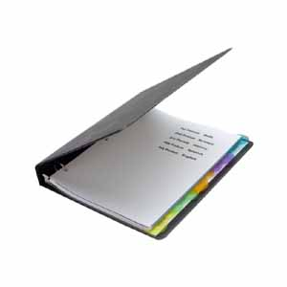

6th Grade Advanced Social Studies

###### Go Bobcats!!!

# The Curriculum:

* a binder to be shared with Science
* dividers

**\***These were on your

school supply list.

Supplies needed:

Sixth grade social studies is composed of four domains: history, geography, economics, and government. Students will explore these four domains in Europe, Latin America, the Caribbean, Canada, and Australia.

## 

## Check out the standards at:

## georgiastandards.org

*Mrs. Caine’s* *2017-2018 Class Syllabus*

North Habersham Middle School

1. Email me at

[jcaine@habershamschools.com](mailto:jcaine@habershamschools.com)

1. My website:

[mrsjcaine.weebly.com](http://mrsjcaine.weebly.com/" \t "_blank)

This will have lesson plans, notes, powerpoints, and enrichment activities on it!

1. Sign up to get Remind texts. I’ll inform you about upcoming quizzes and tests regularly. Text the message @caine6ssa to the number 81010 to receive remind texts.
2. Call me during my planning period

(8:20-9:50) at 706-754-2915.

Classroom Grading:

50% daily grades and homework

50% quizzes and tests

### Let’s stay connected:

Notebook Checks:

Classroom Expectations:

Students are expected to treat themselves and others with respect at all times. Failure to do so on a chronic basis will result in disciplinary action.

Students will be required to keep an organized notebook for social studies. These will be graded for completion and sequence periodically throughout the year. Students will be made aware of notebook checks in advance, as they will count as a daily grade.

Sixth grade is a crucial year for developing organizational skills. We find that notebook checks help students learn those skills.